https://www.jdoodle.com/embed/v0/6d3V
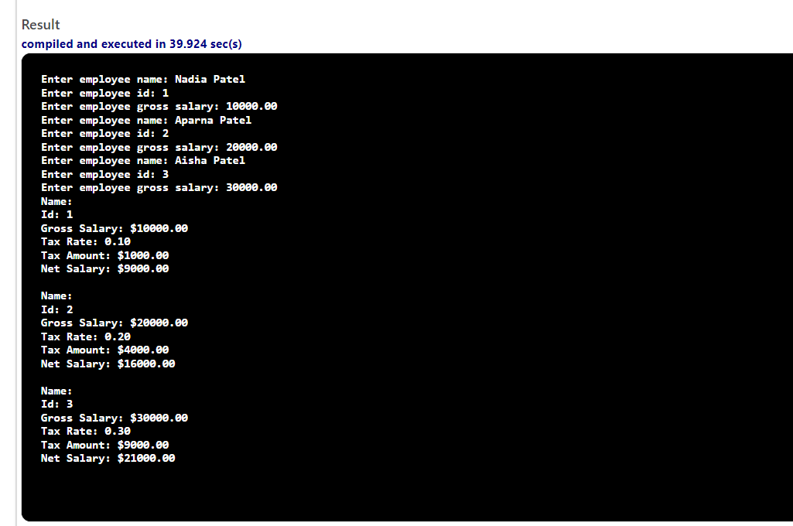

#include <iostream>
#include <iomanip>

using namespace std;

struct Employee
{
string name;
int id;
double grossSalary;
double taxRate;
double taxAmount;
double netSalary;
};

Employee inputEmployee()
{
Employee emp;
cout << "Enter employee name: ";
getline(cin, emp.name);
cout << "Enter employee id: ";
cin >> emp.id;
cout << "Enter employee gross salary: ";
cin >> emp.grossSalary;
cin.ignore();

return emp;
}

Employee computeTax(Employee emp)
{
emp.taxAmount = emp.grossSalary * emp.taxRate;
return emp;
}

void computeNetSalary(Employee &emp)
{
emp.netSalary = emp.grossSalary - emp.taxAmount;
}

void displayEmployee(Employee emp)
{
cout << fixed << showpoint << setprecision(2);
cout << "Name: " << emp.name << endl;
cout << "Id: " << emp.id << endl;
cout << "Gross Salary: $" << emp.grossSalary << endl;
cout << "Tax Rate: " << emp.taxRate << endl;
cout << "Tax Amount: $" << emp.taxAmount << endl;
cout << "Net Salary: $" << emp.netSalary << endl << endl;
}

int main()
{
Employee emp1, emp2, emp3;

emp1 = inputEmployee();
emp1.taxRate = 0.1;
emp1 = computeTax(emp1);
computeNetSalary(emp1);

emp2 = inputEmployee();
emp2.taxRate = 0.2;
emp2 = computeTax(emp2);
computeNetSalary(emp2);

emp3 = inputEmployee();
emp3.taxRate = 0.3;
emp3 = computeTax(emp3);
computeNetSalary(emp3);

displayEmployee(emp1);
displayEmployee(emp2);
displayEmployee(emp3);

return 0;
}

